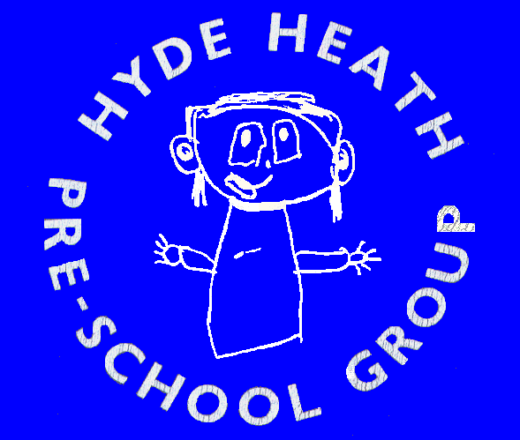

Pre-School Visit to Odds Park Farm, Wooburn Common,

High Wycombe, Bucks, HP10 0LX Thursday 12 May 2011

Name of Child …………………………………………………………………………

We will/will not be going on the outing to Odds park Farm

I will/will not be accompanying my child on the

outing……………………………………………………………………………………..

I do have an annual pass for the Farm - yes/no

Adults @ £7.70 …………….

Children aged 2-16 years @ £6.90 ………………

Bags of Feed @ 30p per bag …………..

Total Cost …………………………………….

Please make cheques payable to Hyde Heath Pre-School. All forms to be returned to the Supervisors by Friday 1 April 11.

Comments:

