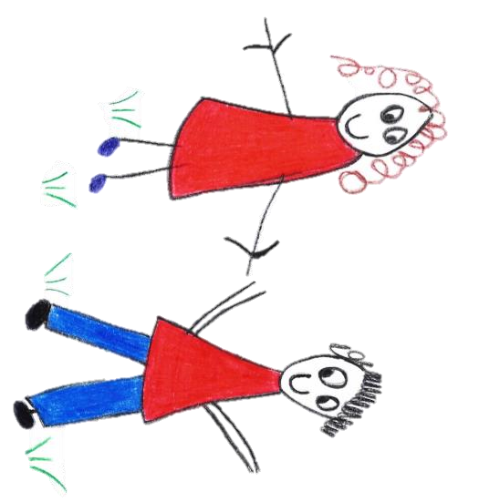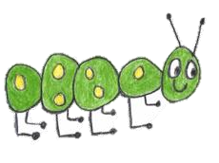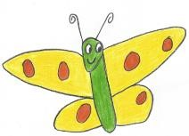

Hyde Heath Pre-school
Have fun and learn!
Registered Charity Number 1020591
Hyde Heath Infant School, Weedon Hill, Hyde Heath, Amersham, Bucks, HP6 5RW
Tel: 01494 782845

Dear All,
This half term we are planning lots of exciting activities for your children. We will be looking at celebrations from around the World- Holi and Easter. As we enter the Spring season we will be researching new life by observing plants, buds, chicks etc. where we will be spending more time in the woods and on the common looking for the signs of Spring and comparing our findings to other seasons. Math’s is included in all that we do, we will continue to problem solve and offer to challenge children’s thinking during activities throughout the day.
Topic | Focus and Learning Spring 2
Animals and Animal Habitats
- Matching Baby and adult animals
- Find out the names of baby animals
- Caring of animals- what do they need to stay healthy?
- Visit from a Vet
- Exploring habitats in our environment, who do they belong to?
- Creating animal homes and clay animals
Holi
- What is Holi and how is it celebrated? Exploring Traditions
- Painting with Colour- Using different methods to paint- Messy play and encouraging mark making.
- Colour collages using petals
- The story of Holi
- Holi songs to learn
Literacy and Room on the Broom
- World Book Day- Dressing up and discussing favourite stories.
- listen to stories with increasing attention & recall
- Describe main story settings, events & principal characters.
- Room on the Broom activities- retelling the story using props for imaginative play.
- Inviting Parents to come and read with the children
Spring and New Life (Baby Animals)
- Exploring our natural environment- looking at change and making comments on change.
- Walks to the common.
- Use our senses to investigate objects and talk about what we have found.
- Have fun searching for objects in our environment
- Spring Crafts
Easter
- What is Easter
- How do we celebrate Easter?
- Easter egg hunt- counting eggs
- Pattern and shape- eggs

You are more than welcome to take part in our activities at home. Our topic information is displayed inside the Pre-School by the notice board. If you would like any further ideas to support your child at home, please do speak with a member of staff who will be able to support you.
As the term progresses so does the children’s interests, please be aware that we plan through children’s interests, so our activities may change.

Sounds
Letters and Sounds are embedded throughout the day in Pre-School through rhymes, discussion and the activities that take place. If you would like to support your child at home with the Letters and Sounds programme, please feel free to look at the programme we use at http://www.letters-and-sounds.com. We teach Phase 1 in Pre-School and all the activities are differentiated to the age and ability of the children. Reading stories and asking your child to discuss the characters, objects and story plot is a valuable part of learning to read. Hearing sounds in the environment, playing with musical instruments and making music is also important before learning sounds in words as it supports the skill of listening.
Butterflies
In Pre-School- It is important to remember that we are teaching the children pure sounds. To help you understand a little more please have a look at the following YouTube video with the jolly phonics songs and actions. https://www.youtube.com/watch?v=eCjJYB07aSU.

Caterpillars
The caterpillars will continue to listen to environmental sounds and start to play group listening games. Playing games like sound lotto will encourage children to take turns in conversation where they can share ideas and listen to each other.

Dates
World Book Day: Thursday 7th March
Parents Evening: Tuesday 12th March 3.10pm – 4.30pm
Trip to Shortenills: Tuesday 26th March – All day
End of Spring Term: Friday 5th April (Pre-School closes at 1.30pm)
Easter Egg Hunt: Saturday 6th April (details to be confirmed)

Packed Lunches
Please consider what your child would eat in their packed lunch. We encourage a healthy lunchbox containing fruit and vegetables. We discourage sweets and chocolate bars due to the high sugar content. We have a strict no nuts/nut products policy within pre-school due to allergies, this includes chocolate spread. Anything with nuts or sesame seeds in will not be allowed. I have attached a leaflet to this email with information regarding a healthy lunchbox, please do take the time to read it. We ask you to provide water only in your child’s water bottle. Water in Pre-School is easily accessible, children are welcome to drink when they feel they need to do so (or encouraged to do so).

Committee Members
Would you like to be on the Committee?
Being a Registered Charity your Pre- School really does rely on the work of everyone- staff and parents, helping to make it an enjoyable place for your children to learn. We are currently looking for new Committee Members. If you think this is something you may be interested in, please do speak with Mrs Rutherford or Alison Cordiner (Chair) who will be more than happy to provide you with more information.

If you have any questions with regards to your child or Pre-School please do not hesitate to speak with your child’s Key Worker or our Manager – Mrs Claire Rutherford, who can be emailed at: manager@hydeheathpreschool.org.uk

The Pre-School team thank you for your continued support.

Kind regards

Mrs Rutherford – Pre-School Manager, First Aider and Designated Safeguarding Officer

Mrs Boldt – Deputy Pre-School Leader, First Aider, SENDCO and Designated Safeguarding Officer

Mrs Chapman – Pre-School Practitioner (Level 2) and First Aider

Mrs Singh- Pre-School Practitioner (Level 3)

Mrs Wallace –Administrator

