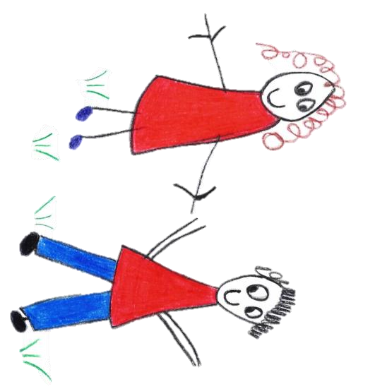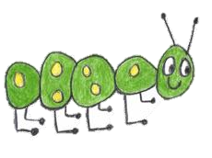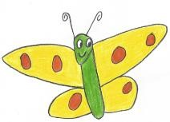

Hyde Heath Pre-school
Have fun and learn!
Registered Charity Number 1020591
Hyde Heath Infant School, Weedon Hill, Hyde Heath, Amersham, Bucks, HP6 5RW
Tel: 01494 782845

6.10. Epidemic and Pandemic Policy and Procedures (Staff) (Covid 19)

Policy statement
Hyde Heath Pre-School intend to use this policy to provide precautionary measures to minimise transmission risks of disease in the setting during an epidemic or pandemic. It also states ideas for continuity of business if allowed.

This Policy defines and assists the operating arrangements in place within the Pre-School that assures compliance to the Government and leading bodies requirements with relation to the outbreak of a pandemic such as Covid19. This information builds upon our current procedures for areas such as Safeguarding, Child Protection and Equality and Diversity, however new practices may emerge as the situation continues. The policy and considerations may evolve and be built upon as the situation deepens and new precautionary measures have been introduced and practices have been reflected upon.

Procedures
The fundamental principles to be outlined in this policy are set out to ensure physical distancing is enabled and implement good hygiene practices as well as avoiding meeting infected children and adults or anyone displaying symptoms. It states the protective measures put in place for children, parents/carers, and staff as best as possible to ensure the risk of transmission is reduced. We will continue to follow our other policies if they do not conflict with this policy and be guided by the EYFS as best as we can. The main areas we will be considering are:

- Minimising contact with individuals who are unwell
- Maintaining personal and respiratory hygiene (handwashing, catch it, kill it, bin it)
- Ensuring cleanliness of the environment (especially frequently touched surfaces and resources)
- Minimising general contact and mixing of both adults and children
- Care routines and equipment from home
- Wellbeing and Education
- The use of Protective and Personal Equipment (PPE)
- Testing
Physical Distancing/grouping
- Children are not expected to attend in small ‘bubbles’ but limited amount of children may be in attendance. This is to minimise contact with others and mixing. Staff may exercise their own judgement during the day for the high standards of safety for all children.
- Children in small groups should have the same staff team caring for them wherever possible to limit the amount of people meeting each other.
- Outdoor spaces should be utilised as much as possible.

Care Routines
- Care routines including provision of snack time, lunch time, nappy changing, and toileting will be arranged to support social distancing and cross contamination.
- Lunch boxes will be kept apart and within your child’s group.
- Key workers may be changed due to staffing – you will be informed who your key children will be.
- Lunch – lunch boxes should be kept away from other food, lunch boxes etc. as much as possible and should not touch.
Wellbeing
- Staff will be supported by management and adhere to the Wellbeing policy to help them to
to understand the steps, they can take to keep themselves safe.

Staff
Attendance
- Staff are to only attend preschool if they are symptom free, have completed the required isolation period or achieved a negative test result. All staff and their household are eligible for testing if they display symptoms.
- Staff should not attend Pre-School if they have received confirmation that they should shield due to health reasons. A letter of confirmation should be passed to the employer if this is the case.
- Consideration will be given to limiting the number of staff in the preschool at any one time to only those required to care for the expected occupancy levels on any given day
- Staff hours, days they work, and length of day may change to meet childcare demands and considerations within this policy.
- During the Covid 19 pandemic your working hours will be as normal unless there is a change to Government guidelines.
- If staff hours are changed and there is a reduce in your usual working hours, but you are still receiving full pay, then work from home must be completed. This may include training, assessments, planning or any other work seemed reasonable by your Manager.
- Staff are also to be on call if an emergency arises at Pre-School and you are needed to come in – this is during your normal paid working hours.

Physical distancing/ grouping /safety
- Staff will complete a risk assessment and health declaration before opening to address any risks from the virus to ensure sensible measures are in place to control risks.
- Staff to be informed of measures in place and sign a disclaimer to state they have read and understood the preschool policies and procedures.
- Emergency revisions to the EYFS may have been implemented which provides some flexibility on ratios and qualifications to make this feasible.
- Staff may be required to oversee areas including the outdoors to minimise their contact with surfaces etc. This includes potentially working from one table if tabletop toys are available. Staff will be responsible to ensure appropriate cleaning takes place and enough ventilation is in the room such as opening windows. If doors are open, ensure the safety of the children is maintained.
- Staff members are to avoid physical contact with each other including handshakes, hugs etc and maintain a 2-meter distance as much as possible.
- Staff to wear fresh, clean clothes for each session.
- Staff to wear masks in physical distancing can not be avoid i.e. in corridors etc

Training
- Where possible, meetings and training sessions should be conducted through virtual conferencing unless a 2-meter rule can be implemented in setting.
- All staff members will receive appropriate instruction and training in infection control and the standard operating procedure and risk assessments within which they will be operating.
- Online training may be available to allow training levels to be maintained if appropriate.
First Aid
- The Health and Safety Executive published guidance on first aid during coronavirus (COVID-19) which will support local risk assessments and provides guidance for first aiders. Treating any casualty properly should be the first concern. Where it is necessary for first aid provision to be administered in proximity, those administering it should pay particular attention to sanitation measures immediately afterwards, including washing hands

Travel
- Wherever possible staff are required to travel to preschool by walking or if not possible, using their own transport.
- If public transport is necessary, current guidance on the use of public transport must be followed.
- Outings from the preschool into the local community will go ahead if safe to do so and ensure mixing with members of the public does not happen– This will be monitored, and a full risk assessment will be in place.
- Staff are advised not to travel to countries or areas that require an isolation period upon arrival or return due to the need of staff to child ratios. If travel is absolutely necessary this must be discussed with the Manager and Government guidelines must be followed.

Hygiene and Health & Safety
Hand Washing
- All staff must wash their hands upon arrival at the nursery for at least 20 seconds. Hand Gel is also provided and should be used accordingly.
- Staff are to be encouraged to wash their hands frequently, this includes before and after eating food, after visiting the toilet or being outdoors, after sneezing, blowing their nose or coughing and dealing with unwell people.
Cleaning
- All staff are responsible for the cleaning of the premises
- The cleaning of furniture, surfaces and children’s toys and equipment are to be implemented after each use.
- Toilet area and hand washing facilities are to be cleaned and sanitised regularly and cleaned thoroughly every night.
- A deep clean will take place after a child has become ill in the area they were waiting.
- The kitchen area will hold one adult at a time and surfaces will be washed down – first with warm soapy water and then with disinfectant.
- The kitchen floor will be washed at the end of the day
- The Pre-School floor will be washed at the end of the day
Waste disposal
- All waste will be disposed of in a hygienic and safe manner following government guidelines.
- Tissues are to be immediately disposed of and placed in a bin with a bag, lid and foot pedal.
Laundry
- Items such as towels and flannels are not to be shared.
Risk assessment
- The setting and all activity will be risk assessed before opening or going ahead to address the risks from the virus and due consideration given to any adaptations to usual practice. Sensible measures will be put in place and policies and procedures followed.
- Staff will remove resources which cannot be easily wiped down or washed and will not be used.
- Play food, play cutlery and crockery etc. will be removed or anything else which may be ‘mouthed’ by many children.
- Baking, food play, sand and finger painting will be allowed if safe to do so.

PPE
- Government guidance is that PPE is not required for general use in early years settings to protect against COVID- 19 transmission.
- PPE will continue to be worn and disposed of as normal for nappy changing, one to one care and the administration of first aid.
- If a child shows symptoms, staff will wear a face mask, visor, disposable gloves, and apron if a 2-meter distance cannot always be maintained. PPE will be disposed of following government guidelines
- After dealing with an ill child who displayed symptoms the staff member will continue to wear PPE and clean the affected area with disinfectant.
- All PPE should be removed and disposed of following current government guidelines, the staff member is to wash their hands for at least 20 seconds.
- The staff member who supported the unwell child does not need to go home unless they are developing symptoms themselves.

Premises Building
- Windows are to be kept open where possible to ensure good levels of ventilation. If doors are opened, we will ensure the children’s safety is maintained.

Supplies Procurement & monitoring
- The preschool will ensure an adequate supply of essential supplies and contingency plans such as additional suppliers are in place to minimise the impact of any shortages of supplies.
- The preschool will not be able to operate without essential supplies required for ensuring infection control.
- A monitoring system for the usage of PPE is essential to ensure that a supply of stock is available to all who require it as and when required to meet the operational needs of the setting.
- In case the supply of food is interrupted, procedures must be implemented to ensure the appropriate food alternatives are sourced and normal food safety and hygiene processes are followed.
- Food brought for snack will be carefully handled and collected by a member of staff – This will not go into their own home. Fruit and vegetables will be handled with gloves and washed.

Responding to a suspected case of Cocid-19
- In the event of a child developing suspected coronavirus symptoms whilst attending the setting, children are to be collected as soon as possible and isolate at home in line with the current NHS guidance.
- Whilst waiting for the child to be collected the child will be isolated from others in an arranged area. Windows will be opened for ventilation.
- The staff member responsible for the child during this time will wear PPE such face mask, visor disposable gloves and apron will be worn.
- The area will be thoroughly cleaned, immediately if the area cannot be left unvisited, and if the area can be left unvisited then cleaned after 72 hours.
- The person responsible for cleaning will be the person dealing with the unwell child and should continue to wear their PPE. This will then be disposed of according to current government guidelines.
- In the event of a staff member developing suspected coronavirus symptoms whilst working at the Pre-School, they are to return home immediately and isolate at home in line with the NHS guidance. Current testing advice for themselves and their household will need to be implemented.
- It may be necessary for the group in which a suspected/confirmed case of Covid-19 to self-isolate for 14 days.

Staff are asked to read this policy, Well-being policy and Parents and Child Epidemic and Pandemic Policy for Parents and Children as well as Government guidelines. Once read, we ask you to sign that you have read, understood, and agree to the terms set out. This will also be an adaptation of your current contract.

Legal framework
- Coronavirus Act 2020
- Health and Safety at Work Act (1974)
- Health and Safety Executive (HSE),
- Public Health England (PHE)
- World Health Organisation (WHO).
Further advice and guidance
Advice from but not limited to:
- The Chief Medical Officer
- NHS England
- Local Authority (LA) and Department for Education (DfE).
- The policy also has regard to Ofsted and Early Years Foundation Stage (EYFS) guidance where appropriate.

This policy was adopted by | Hyde Heath Pre-School
On | 25.09.2020
Date to be reviewed | Ongoing
Signed on behalf of the provider
Name of signatory | Carrie Swallow
Role of signatory (e.g. chair, director or owner) | Chair

