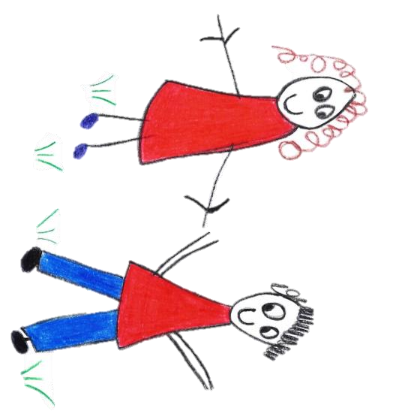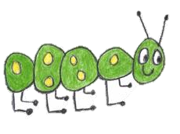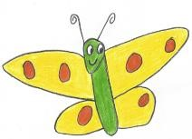

Hyde Heath Pre-school
Have fun and learn!

Registered Charity Number 1020591
Hyde Heath Infant School, Weedon Hill, Hyde Heath, Amersham, Bucks, HP6 5RW
Tel: 01494 782845

8.6 Animals in the setting

Policy statement

Children learn about the natural world, its animals and other living creatures, as part of the Learning and Development Requirements of the Early Years Foundation Stage. This may include contact with animals, or other living creatures, either in the setting or on visits. We aim to ensure that this is in accordance with sensible hygiene and safety controls.

Procedures

Animals in the setting as pets
- We take account of the views of parents and children when selecting an animal or creature to keep as a pet in the setting, as well as any allergies or issues that individual children may have any animals or creatures.
- We carry out a risk assessment with a knowledgeable person accounting for any hygiene or safety risks posed by the animal or creature.
- We provide suitable housing for the animal or creature and ensure this is cleaned out regularly and is kept safely.
- Our staff are knowledgeable of the pet’s welfare and dietary needs and ensure that the correct food is offered, at the right times.
- We make arrangements for weekend and holiday care for the animal or creature.
- We register with the local vet and take out appropriate pet care health insurance.
- We make sure all vaccinations and other regular health measures, such as de-worming, are up-to-date and recorded.
- We teach children the correct handling and care of the animal or creature and supervise them at all times.
- We ensure that children wash their hands after handling the animal or creature and do not have contact with animal soil or soiled bedding.
- We wear disposable gloves when cleaning housing or handling soiled bedding.
- If animals or creatures are brought in by visitors to show the children, they are the responsibility of their owner.
- The owner carries out a risk assessment, detailing how the animal or creature is to be handled and how any safety or hygiene issues will be addressed.

Visits to farms
- Before a visit to a farm, we carry out a risk assessment - this may take account of safety factors listed in the farm’s own risk assessment, which should be viewed.
- We contact the venue in advance of the visit to ensure that there has been no recent outbreak of E.coli or other infections. If there has been an outbreak, we will review the visit and may decide to postpone it.
- We follow our outings procedure.
- Children wash and dry their hands thoroughly after contact with animals.
- Outdoor footwear worn to visit farms is cleaned of mud and debris as soon as possible on departure and should not be worn indoors.
- We advise staff and volunteers who are, or may be, pregnant to avoid contact with ewes and to consult their GP before the visit.

Legal framework

- The Management of Health and Safety at Work Regulations (1999)
Further guidance

- Health and Safety Regulation…A Short Guide (HSE 2003)
This policy was adopted by | Hyde Heath Pre-School | (name of provider)
On | September 2020 | (date)
Date to be reviewed | September 2021 | (date)
Signed on behalf of the management committee
Name of signatory
Role of signatory (e.g. chair/owner) | Chair of the Committee

