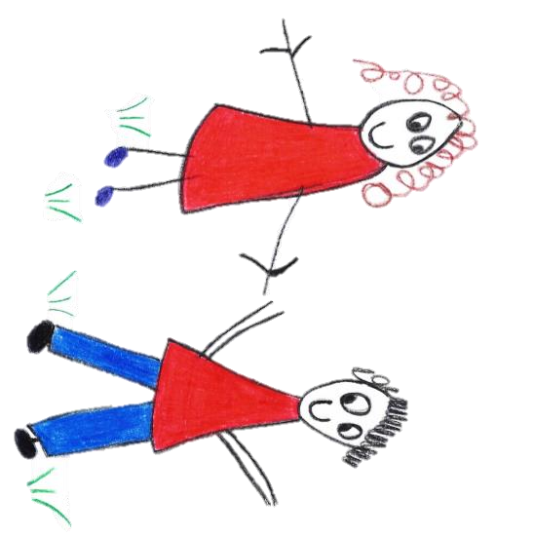

Hyde Heath Pre-school
Have fun and learn!

Registered Charity Number 1020591
Hyde Heath Infant School, Weedon Hill, Hyde Heath, Amersham, Bucks, HP6 5RW
Tel: 01494 782845

8.3 Supervision of children on outings and visits

Policy statement
Children benefit from being taken outside of the premises on visits or trips to local parks, or other suitable venues, for activities which enhance their learning experiences. We ensure that there are procedures to keep children safe on outings; all staff volunteers are aware of and follow the procedures as laid out below.

Procedures
- All off site activity has a clearly identified educational purpose with specific learning and development outcomes.
- There is a designated lead for each excursion who is clear about their responsibility as designated lead.
- We ask parents to sign a general consent on registration for their children to be taken out on local short outings as a part of the daily activities of the setting. This general consent details the venues used for daily activities.
- We assess the risks for each local venue used for daily activities, which is reviewed regularly.
- We always ask parents to sign specific consent forms before major outings; and the risks are assessed before the outing takes place.
- Our manager and all staff taking part in the outing sign off every risk assessment.
- Children with allergies or other specific needs have a separate risk assessment completed i.e. child with allergies visiting a supermarket.
- An excursion will not go ahead if concerns are raised about its viability at any point.
- Any written outing risk assessments are made available for parents to see.
- Our adult to child ratio is high, normally one adult to three children or one adult to two children, depending on their age, sensibility and the type of venue, as well as how it is to be reached.
- A minimum of two staff accompany children on outings. Unless the whole setting is on an outing, a minimum of two staff also remain behind with the rest of the children.
- Named children are assigned to individual staff member to ensure that each child is well supervised, that no child goes astray and that there is no unauthorised access to children.
- Staff frequently count their designated children and ensure hands are held when on the street and crossing the road.
- Parents who accompany us on outings are responsible for their own child only. Where parents have undergone vetting with us as volunteers, they may be included in the adults to child ratio and have children allocated to them.
- Outings are recorded and kept in the setting, stating:
- The date and time of the outing.
- The venue and mode of transport used.
- The names of the staff members assigned to each of the children.
- The time of return.
- We take a mobile phone on outings, as well as supplies of tissues, wipes, spare clothing and nappies, medicines required for individual children, a mini first aid kit, snacks and water. The amount of equipment will vary and be consistent with the venue and the number of children, as well as how long they will be out for. We apply sun cream to children as needed and ensure they are dressed appropriately for the type of outing and weather conditions.
- We take a list of children with us with contact numbers of parents/carers, as well as an accident book and a copy of our Missing Child Policy.
- Records are kept of the vehicles used to transport children, with named drivers and appropriate insurance cover.
- We ensure that seat belts are worn whilst travelling in vehicles and that booster seats and child safety seats are used as appropriate to the age of the child.
- As a precaution, we ensure that children do not eat when travelling in vehicles.
- We ensure that contracted drivers are from reputable companies, do not have unsupervised access to the children and are not included in the ratios.

This policy was adopted by | Hyde Heath Pre-School | (name of provider)
On | September 2020 | (date)
Date to be reviewed | September 2021 | (date)
Signed on behalf of the provider
Name of signatory
Role of signatory (e.g. chair, director or owner) | Chair of the Committee

