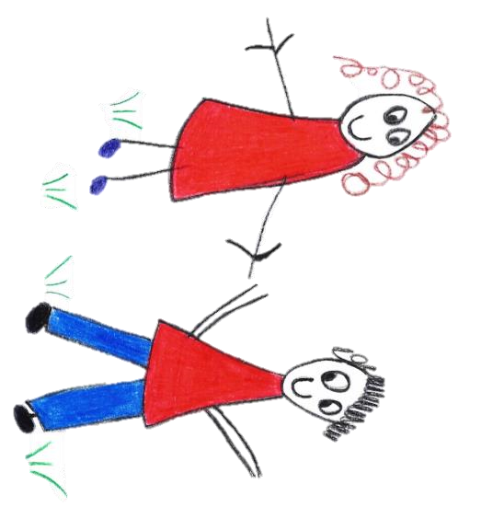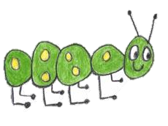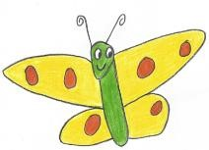

Hyde Heath Pre-school
Have fun and learn!

Registered Charity Number 1020591
Hyde Heath Infant School, Weedon Hill, Hyde Heath, Amersham, Bucks, HP6 5RW
Tel: 01494 782845

8.1 Health and safety general standards

Policy statement
We believe that the health and safety of children is of paramount importance. We make our setting a safe and healthy place for children, parents, staff and volunteers.
- We aim to make children, parents, staff and volunteers aware of health and safety issues and to minimise the hazards and risks to enable the children to thrive in a healthy and safe environment.
- Our member of staff responsible for health and safety is:
Claire Rutherford
- She is competent to carry out these responsibilities.
- She has undertaken health and safety training and regularly updates her knowledge and understanding.
- We display the necessary health and safety poster in
The Pre-School Room

Insurance cover
We have public liability insurance and employers' liability insurance. The certificate for public liability insurance is displayed in:
The Pre-School room near to the entry door.

Procedures

Awareness raising
- Our induction training for staff and volunteers includes a clear explanation of health and safety issues, so that all adults are able to adhere to our policy and procedures as they understand their shared responsibility for health and safety. The induction training covers matters of employee well-being, including safe lifting and the storage of potentially dangerous substances.
- We keep records of these induction training sessions and new staff and volunteers are asked to sign the records to confirm that they have taken part.
- We explain health and safety issues to the parents of new children, so that they understand the part played by these issues in the daily life of the setting.
- As necessary, health and safety training is included in the annual training plans of staff, and health and safety is discussed regularly at our staff meetings.
- We operate a no-smoking policy.
- We make children aware of health and safety issues through discussions, planned activities and routines.

Windows
- Low level windows are made from materials that prevent accidental breakage or we ensure that they are made safe.
- We ensure that windows are protected from accidental breakage or vandalism from people outside the building.
- Our windows are secured so that children cannot climb through them.
- We ensure that any blind cords are secured safely and do not pose a strangulation risk for young children.

Doors
- We take precautions to prevent children's fingers from being trapped in doors.

Floors and walkways
- All our floor surfaces are checked daily to ensure they are clean and not uneven, wet or damaged. Any wet spills are mopped up immediately.
- Walkways are left clear and uncluttered.

Electrical/gas equipment
- We ensure that all electrical/gas equipment conforms to safety requirements and is checked regularly.
- Our boiler/electrical switch gear/meter cupboard is not accessible to the children.
- Fires, heaters, electric sockets, wires and leads are properly guarded and we teach the children not to touch them.
- We check heaters daily to make sure they are not covered.
- There are sufficient sockets in our setting to prevent overloading.
- We switch electrical devices off from the plug after use.
- We ensure that the temperature of hot water is controlled to prevent scalds.
- Lighting and ventilation is adequate in all areas of our setting, including storage areas.

Storage
- All our resources and materials, which are used by the children, are stored safely.
- All our equipment and resources are stored or stacked safely to prevent them accidentally falling or collapsing.

Outdoor area
- Our outdoor area is securely fenced. All gates and fences are child proof and safe.
- Our outdoor area is checked for safety and cleared of rubbish, animal droppings and any other unsafe items before it is used.
- Adults and children are alerted to the dangers of poisonous plants, herbicides and pesticides.
- Our pond is securely covered or otherwise guarded.
- We leave receptacles upturned to prevent collection of rainwater. Where water can form a pool on equipment, it is emptied and cleaned before children start playing outside.
- Our outdoor sand pit is covered when not in use and is cleaned regularly.
- We check that children are suitably attired for the weather conditions and type of outdoor activities; ensuring that suncream is applied and hats are worn during the summer months.
- We supervise outdoor activities at all times; and particular children on climbing equipment.

Hygiene
- We seek information from the Public Health England to ensure that we keep up-to-date with the latest recommendations.
- Our daily routines encourage the children to learn about personal hygiene.
- We have a daily cleaning routine for the setting, which includes the play room, kitchen, rest area, toilets and nappy changing areas. Children do not have unsupervised access to the kitchen.
- We have a schedule for cleaning resources and equipment, dressing-up clothes and furnishings.
- The toilet area has a high standard of hygiene, including hand washing and drying facilities and disposal facilities for nappies.
- We implement good hygiene practices by:
- cleaning tables between activities;
- cleaning and checking toilets regularly;
- wearing protective clothing - such as aprons and disposable gloves - as appropriate;
- providing sets of clean clothes;
- providing tissues and wipes; and

Activities, resources and repairs
- Before purchase or loan, we check equipment and resources to ensure that they are safe for the ages and stages of the children currently attending the setting.
- We keep a full inventory of all items in the setting for audit and insurance purposes.
- The layout of our play equipment allows adults and children to move safely and freely between activities.
- All our equipment is regularly checked for cleanliness and safety, and any dangerous items are repaired or discarded.
- We make safe and separate from general use any areas that are unsafe because of repair is needed.
- All our materials, including paint and glue, are non-toxic.
- We ensure that sand is clean and suitable for children's play.
- Physical play is constantly supervised.
- We teach children to handle and store tools safely.
- We check children who are sleeping at regular intervals of at least every ten minutes. This is recorded with the times checked and the initials of the person undertaking the check.
- If children fall asleep in-situ, it may be necessary to move or wake them to make sure they are comfortable.
- Children learn about health, safety and personal hygiene through the activities we provide and the routines we follow.
- Any faulty equipment is removed from use and is repaired. If it cannot be repaired it is discarded. Large pieces of equipment are discarded only with the consent of the manager and the management team.

Jewellery and accessories
- Our staff do not wear jewellery or fashion accessories, such as belts or high heels, that may pose a danger to themselves or children.
- Parents must ensure that any jewellery worn by children poses no danger; particularly earrings which may get pulled, bracelets which can get caught when climbing or necklaces that may pose a risk of strangulation.
- We ensure that hair accessories are removed before children sleep or rest.

Safety of adults
- We ensure that adults are provided with guidance about the safe storage, movement, lifting and erection of large pieces of equipment.
- We provide safe equipment for adults to use when they need to reach up to store equipment or to change light bulbs.
- We ensure that all warning signs are clear and in appropriate languages.
- We ensure that adults do not remain in the building on their own.
- We record the sickness of staff and their involvement in accidents. The records are reviewed termly to identify any issues that need to be addressed.

Control of substances hazardous to health
- Our staff implement the current guidelines of the Control of Substances Hazardous to Health Regulations (COSHH).
- We keep a record of all substances that may be hazardous to health - such as cleaning chemicals, or gardening chemicals if used and where they are stored.
- Hazardous substances are stored safely away from the children.
- We carry out a risk assessment for all chemicals used in the setting. This states what the risks are and what to do if they have contact with eyes or skin or are ingested.
- We keep all cleaning chemicals in their original containers.
- We keep the chemicals used in the setting to the minimum in order to ensure health and hygiene is maintained. We do not use:
- bleach;
- anti-bacterial soap/hand wash, unless specifically advised during an infection outbreak such as Pandemic flu; or
- anti-bacterial cleaning agents, except in the toilets, nappy changing area and food preparation areas. Anti-bacterial spays are not used when children are nearby.
- Environmental factors are taken into account when purchasing, using and disposing of chemicals.
- All members of staff are vigilant and use chemicals safely.
- Members of staff wear protective gloves when using cleaning chemicals.

Legal framework

- Health and Safety at Work Act (1974)
- Management of Health and Safety at Work Regulations (1999)
- Electricity at Work Regulations (1989)
- Control of Substances Hazardous to Health Regulations (COSHH) (2002)
- Manual Handling Operations Regulations (1992 (As Amended 2004))
- Health and Safety (Display Screen Equipment) Regulations (1992)

Further guidance
- Health and Safety Law: What You Need to Know (HSE Revised 2009)
- Health and Safety Regulation…A Short Guide (HSE 2003)
- Electrical Safety and You: A Brief Guide (HSE 2012)
- Working with Substances Hazardous to Health: What You Need to Know About COSHH (HSE Revised 2009)
- Getting to Grips with Manual Handling - Frequently Asked Questions: A Short Guide (HSE 2011)
This policy was adopted by | Hyde Heath Pre-School | (name of provider)
On | September 2020 | (date)
Date to be reviewed | September 2021 | (date)
Signed on behalf of the provider
Name of signatory
Role of signatory (e.g. chair, director or owner) | Chair of the Committee

