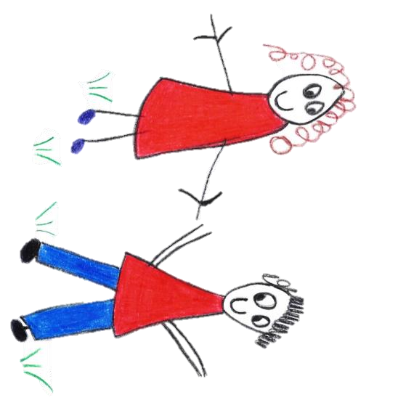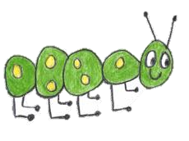

Hyde Heath Pre-school
Have fun and learn!

Registered Charity Number 1020591
Hyde Heath Infant School, Weedon Hill, Hyde Heath, Amersham, Bucks, HP6 5RW
Tel: 01494 782845

8.11 Pre-School Closure Policy

Policy statement
Hyde Heath Pre-School will endeavour to remain open whatever the weather. However, if the local area suffers adverse weather conditions such as heavy snowfall, flooding or high winds, then please check the Pre-school Closures Information. We need to be sure enough staff can make it into work, so that we can run the Pre-school safely with appropriate adult ratios, as well as checking the site is safe. If we need to close whilst in operation, we will keep children safe and ask parents to follow our procedures.
The safety of the children, parents and staff is paramount
EMERGENCY CLOSURE
An emergency / short notice closure will be implemented in the following circumstances:
• When the building is unusable through accidental or malicious damage
• Flooding
• Bad weather – see above.
• The breakdown of the heating system.
• When the building is unusable due to required maintenance work. Where possible we will endeavour to negotiate scheduled work to be carried out during times of closure.
• When an outbreak of illness within Preschool community which requires closure in line with Health Protection Agency (HPA) and Ofsted guidelines.
• When illness levels within the staff body mean, it is impossible to maintain the correct ratios of suitable adults to children.
• When an emergency occurs during the Preschool session which requires us to close early.
We are required by Ofsted to maintain our staff to children ratios. If our staff can get into the setting, the session will run but could result in a shorter period if this is judged to be in the best interests of all attendees.

Procedures
- In the event of any of the above incidents occurring, we will contact the families of the preschool for that session if possible, in advance of the day, usually by email.
- We will inform parents by email or telephone by 8.00am on the day of closure.
- Information of closure will also be posted on our Facebook Page and Website.
- We will inform Bucks County Council of the unexpected closure depending on the circumstances of the closure.
- We will inform the local radio station of our closure.

Emergency closure after a session has started
Procedures
- In the event of an emergency closure after the session has started, parents and carers will be informed by telephone that they are required to collect their child as soon as possible.
- If the closure is due to sickness, the children and all staff who are unaffected will remain on the premises until all children can be collected.
- If the closure is due to an emergency which requires the building to be evacuated, the children will be safely evacuated according to the current Fire Drill procedures. Contact information for all the children will be taken out of the building alongside the daily register. Once the building is evacuated, we will ensure the relevant authorities/emergency services are called. The children will then be taken to a place of safety until such time as they can all be collected by parents and carers. We will contact the parents and carers of the children present. All staff will remain with the children during this time.
- Should any of the above occur, fee’s will still have to be paid and regrettably will not be refunded, nor will sessions be reallocated.

This policy was adopted by | Hyde Heath Pre-School | (name of provider)
On | September 2020 | (date)
Date to be reviewed | September 2021 | (date)
Signed on behalf of the provider
Name of signatory
Role of signatory (e.g. chair, director or owner) | Chair of the Committee

