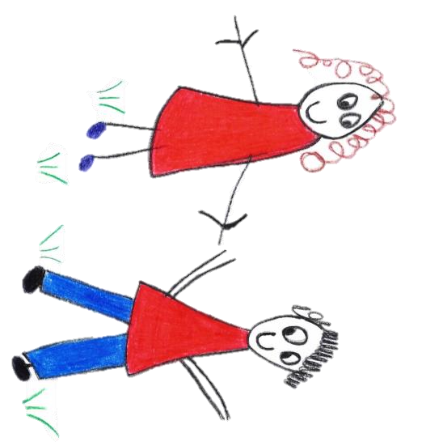

Hyde Heath Pre-school
Have fun and learn!

Registered Charity Number 1020591
Hyde Heath Infant School, Weedon Hill, Hyde Heath, Amersham, Bucks, HP6 5RW
Tel: 01494 782845

8.10 Staff personal safety including home visits

Policy statement

This setting believes that the health and safety of all staff is of paramount importance and that all staff have the right to work in a safe environment. We support safe working both on and off the premises, acknowledging the needs and diversity of children and their family.

Procedures

General
- All staff in the building early in the morning, or late in the evening, ensure doors and windows are locked.
- Where possible, at least the first two members of staff to arrive in the building arrive together, and the last two members of staff in the building leave together.
- Visitors are generally only allowed access with prior appointments and only admitted once their identity has been verified.
- Minimal petty cash is kept on the premises.
- Members of staff make a note in the diary of meetings they are attending, who they are meeting and when they are expected back.
- Managers have good liaison with local police and ask for advice on safe practice where there are issues or concerns.

Home visits
Where staff members conduct home visits, this is done at the manager’s discretion and the following health and safety considerations apply:
- Prior to a home visit the key person and manager undertake a risk assessment that is specific to the visit being undertaken.
- Members of staff normally do home visits in pairs – usually the manager/deputy manager with the key person.
- Each home visit is recorded in the diary with the name and address of the family being visited, prior to the visit taking place.
- Staff alert an agreed contact person in the setting when they are leaving to do the home visit and advise on their expected time of return.
- If there is any reason for staff to feel concerned about entering premises, they do not do so, for example, if a parent appears drunk.
- Members of staff carry a mobile phone when going out on a home visit.
- Staff identify an emergency word/phrase, which is made known to all staff in the setting, so that if they feel extremely threatened or in danger on a home visit they can covertly alert other members of staff via a telephone call to the situation. Use of the agreed word/phrase will initiate an immediate 999 call to be made.
- If staff do not return from the home visit at the designated time, the contact person attempts to phone them and continues to do so until they make contact.
- If no contact is made after a reasonable amount of time has passed, the contact person rings the police.

Dealing with agitated parents in the setting
- If a parent appears to be angry, mentally agitated or possibly hostile, two members of staff will lead the parent away from the children to a less open area, but will not shut the door behind them.
- If the person is standing, staff will remain standing.
- Members of staff will try to empathise and ensure that the language they use can be easily understood.
- Staff will speak in low, even tones, below the voice level of the parent.
- Members of staff will make it clear that they want to listen and seek solutions.
- If the person makes threats and continues to be angry, members of staff make it clear that they will be unable to discuss the issue until the person stops shouting or being abusive, while avoiding potentially inflammatory expressions such as ‘calm down’ or ‘be reasonable’.
- If threats or abuse continues, members of staff will explain that the police will be called and emphasise the inappropriateness of such behaviour in front of children.
- After the event, details are recorded in the child’s personal file together with any decisions made with the parents to rectify the situation and any correspondence regarding the incident.

This policy was adopted at a meeting of | Hyde Heath Preschool | (name of provider)
Held on | September 2020 | (date)
Date to be reviewed | September 2021 | (date)
Signed on behalf of the management committee
Name of signatory
Role of signatory (e.g. chair/owner) | Chair of the Committee

