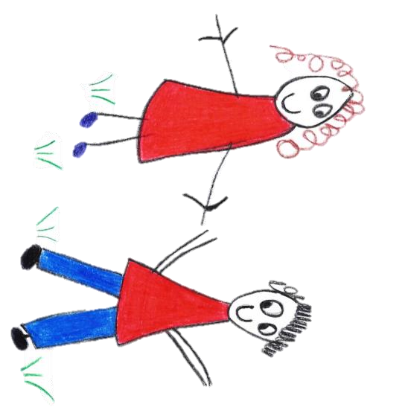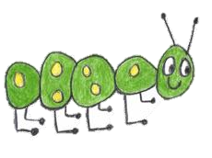

Hyde Heath Pre-school
Have fun and learn!

Registered Charity Number 1020591
Hyde Heath Infant School, Weedon Hill, Hyde Heath, Amersham, Bucks, HP6 5RW
Tel: 01494 782845

6.8 Individual Health Plan
This form must be used alongside the individual child’s registration form which contains emergency parental contact and other personal details.
Date completed: |  | Review date:
Child’s details:
Full name: |  |  |  |  | Date of birth:
Address:
Allergies:
Medical condition/diagnosis
Medical needs and symptoms:
Daily care requirements:
Medication details (inc. expiry date/disposal)
Storage of medication:
Procedure for administering medication (Continue on reverse if necessary):
Names of staff trained to carry out health plan procedures and administer medication:
Claire Rutherford, Louise Boldt
Other information:
Date risk assessment completed:
Risk assessment details:
Describe what constitutes an emergency for the child, what procedures will be taken if this occurs and the names of staff responsible for an emergency situation with the child:
Child’s main carer(s)
- Name: |  | Relationship to child:
Contact number(s):
- Name: |  | Relationship to child:
Contact number(s):

General Practitioner’s details:
Name: |  | Contact number:
Address:
Clinic of Hospital details (if app):
Name: |  | Contact number:
Address:
Declaration
I have read the information in this health plan and have found it to be accurate. I agree for the recorded procedures to be carried out:
Name of parent: |  | Date:
Signature:
Name of key person: |  | Date:
Signature:
Name of manager: |  | Date:
Signature:
Date:

For children requiring lifesaving or invasive medication and/or care, for example, rectal diazepam, adrenaline injectors, Epipens, Anapens, JextPens, maintaining breathing apparatus, changing colostomy or feeding tubes, you must receive approval from the child’s GP/consultant, as follows:
I have read the information in this Individual Health Plan and have found it to be accurate.
Name of GP/consultant: |  | Date:
Signature:
To be reviewed at least every six months, or as and when needed.

Copied to parents and child’s personal file (with registration form)

