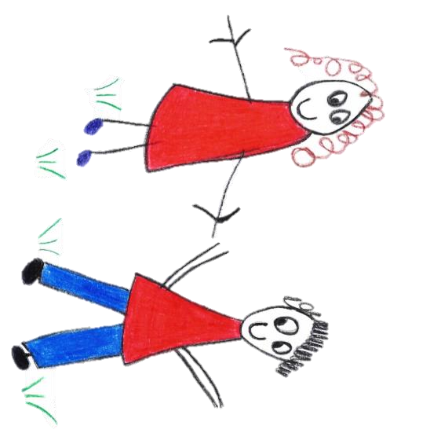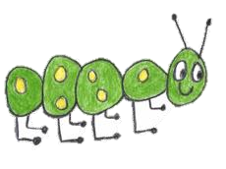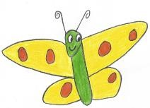

Hyde Heath Pre-school
Have fun and learn!

Registered Charity Number 1020591
Hyde Heath Infant School, Weedon Hill, Hyde Heath, Amersham, Bucks, HP6 5RW
Tel: 01494 782845

6.4 Nappy changing

Policy statement

No child is excluded from participating in our setting who may, for any reason, not yet be toilet trained and who may still be wearing nappies or equivalent. We work with parents towards toilet training, unless there are medical or other developmental reasons why this may not be appropriate at the time.

We provide nappy changing facilities and exercise good hygiene practices in order to accommodate children who are not yet toilet trained.

We see toilet training as a self-care skill that children have the opportunity to learn with the full support and non-judgemental concern of adults.

Procedures

- Our key persons have personalised changing times for the children in their care who are in nappies or ‘pull-ups’; and change nappies according to this schedule, or more frequently where necessary.
- We encourage young children from two years to normally wear pull ups, or other types of trainer pants, as soon as they are comfortable with this and if their parents agree.
- Our key persons undertake changing children in their key groups; back up key persons change them if the key person is absent.
- Young children are changed within sight of other staff whilst maintaining their dignity and privacy at all times.
- Our changing area is warm, with a safe area to lay children and no bright lights shining down in their eyes. There are objects of interest to take the child’s attention.
- Each child has their own bag to hand with their nappies or pull ups and changing wipes.
- Our staff put on gloves and aprons before changing starts and the areas are prepared. Paper towel is put down on the changing mat freshly for each child. Gloves are not always required for a wet nappy where there is no risk of infection, however, gloves are always available for those staff who choose to wear them. Gloves are always work for a ‘soiled’ nappy.
- All our staff are familiar with our hygiene procedures and carry these out when changing nappies.
- Our staff never turn their back on a child or leave them unattended whilst they are on the changing mat.
- We are gentle when changing; we avoid pulling faces and making negative comments about ‘nappy contents’.
- We do not make inappropriate comments about children’s genitals when changing their nappies.
- In addition, we ensure that nappy changing is relaxed and a time to promote independence in young children.
- We encourage children to take an interest in using the toilet; they may just want to sit on it and talk to a friend who is also using the toilet.
- We encourage children to wash their hands, and have soap and towels to hand. They should be allowed time for some play as they explore the water and the soap.
- We do not use anti-bacterial hand wash liquid or soap for young children; young skin is quite delicate and anti-bacterial products kill off certain good bacteria that children need to develop their own natural resistance to infection.
- Older children access the toilet when they have the need to and are encouraged to be independent.
- We dispose of nappies and pull ups hygienically. Any soil (faeces) in nappies or pull ups is bagged and put in the bin. Cloth nappies, trainer pants and ordinary pants that have been wet or soiled are rinsed and bagged for parents to take home.
- We have a ‘duty of care’ towards children’s personal needs. If children are left in wet or soiled nappies/pull ups in the setting this may constitute neglect and will be a disciplinary matter.

This policy was adopted by | Hyde Heath Pre-School | (name of provider)
On | September 2020 | (date)
Date to be reviewed | September 2021 | (date)
Signed on behalf of the provider
Name of signatory
Role of signatory (e.g. chair, director or owner) | Chair of the Committee

