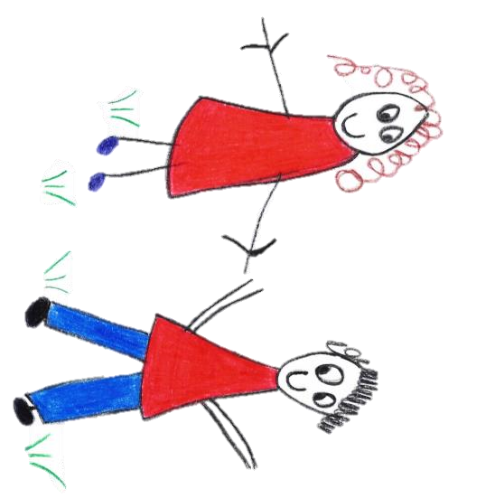

Hyde Heath Pre-school
Have fun and learn!

Registered Charity Number 1020591
Hyde Heath Infant School, Weedon Hill, Hyde Heath, Amersham, Bucks, HP6 5RW
Tel: 01494 782845

6.3 Recording and reporting of accidents and incidents

Policy statement

We follow the guidelines of the Reporting of Injuries, Diseases and Dangerous Occurrences Regulations (RIDDOR) for the reporting of accidents and incidents. Child protection matters or behavioural incidents between children are not regarded as incidents and there are separate procedures for this.

Procedures

Our accident book:
- is kept in a safe and secure place;
- is accessible to our staff and volunteers, who all know how to complete it; and
- is reviewed at least half termly to identify any potential or actual hazards.

Reporting accidents and incidents
- Ofsted is notified as soon as possible, but at least within 14 days, of any instances which involve:
- food poisoning affecting two or more children looked after on our premises;
- a serious accident or injury to, or serious illness of, a child in our care and the action we take in response; and
- the death of a child in our care.
- Local child protection agencies are informed of any serious accident or injury to a child, or the death of any child, while in our care and we act on any advice given by those agencies.
- Any food poisoning affecting two or more children or adults on our premises is reported to the local Environmental Health Department.
- We meet our legal requirements in respect of the safety of our employees and the public by complying with RIDDOR. We report to the Health and Safety Executive (HSE):
- Any work-related accident leading to an injury to a member of the public (child or adult), for which they are taken directly to hospital for treatment.
- Any work-related accident leading to a specified injury to one of our employees. Specified injuries include injuries such as fractured bones, the loss of consciousness due to a head injury, serious burns or amputations.
- Any work-related accident leading to an injury to one of our employees which results in them being unable to work for seven consecutive days. All work-related injuries that lead to one of our employees being incapacitated for three or more days are recorded in our accident book.
- When one of our employees suffers from a reportable occupational disease or illness as specified by the HSE.
- Any death, of a child or adult, that occurs in connection with a work-related accident.
- Any dangerous occurrences. This may be an event that causes injury or fatalities or an event that does not cause an accident, but could have done; such as a gas leak.
- Information for reporting incidents to the Health and Safety Executive is provided in the Pre-school Learning Alliance's Accident Record publication. Any dangerous occurrence is recorded in our incident book (see below).

Accidents at Home
- If a child occurs an accident at home and results in visible injury, we require you to fill in an ‘Accident at Home’ form detailing your child’s injury.
- The ‘Accident at Home’ form must be signed and dated.
- Accidents at home are to be discussed with your child’s Keyperson before the start of their session.

Incident book
- We have ready access to telephone numbers for emergency services, including the local police. Where we are responsible for the premises we have contact numbers for the gas and electricity emergency services, and a carpenter and plumber. Where we rent premises we ensure we have access to the person responsible and that there is a shared procedure for dealing with emergencies.
- We ensure that our staff and volunteers carry out all health and safety procedures to minimise risk and that they know what to do in an emergency.
- On discovery of an incident, we report it to the appropriate emergency services – fire, police, ambulance – if those services are needed.
- If an incident occurs before any children arrive, our manager risk assesses this situation and decides if the premises are safe to receive children. Our manager may decide to offer a limited service or to close the setting.
- Where an incident occurs whilst the children are in our care and it is necessary to evacuate the premises/area, we follow the procedures in our Fire Safety and Emergency Evacuation Policy or, when on an outing, the procedures identified in the risk assessment for the outing.
- If a crime may have been committed, we ask all adults witness to the incident make a witness statement including the date and time of the incident, what they saw or heard, what they did about it and their full name and signature.
- We keep an incident book for recording major incidents, including some of those that that are reportable to the Health and Safety Executive as above.
- These incidents include:
  - a break in, burglary, or theft of personal or our setting's property;
  - an intruder gaining unauthorised access to our premises;
  - a fire, flood, gas leak or electrical failure;
  - an attack on an adult or child on our premises or nearby;
  - any racist incident involving families or our staff on the setting's premises;
  - a notifiable disease or illness, or an outbreak of food poisoning affecting two or more children looked after on our premises;
  - the death of a child or adult; and
  - a terrorist attack, or threat of one.
- In the incident book we record the date and time of the incident, nature of the event, who was affected, what was done about it or if it was reported to the police, and if so a crime number. Any follow up, or insurance claim made, is also recorded.
- In the event of a terrorist attack, we follow the advice of the emergency services with regard to evacuation, medical aid and contacting children's families. Our standard Fire Safety and Emergency Evacuation Policy will be followed and our staff will take charge of their key children. The incident is recorded when the threat is averted.
- In the unlikely event of a child dying on our premises, the emergency services are called and the advice of these services are followed.
- The incident book is not for recording issues of concern involving a child. This is recorded in the child's own file.

Education Inspection Framework
- As required under the Education Inspection Framework, we maintain a summary record of all accidents, exclusions, children taken off roll, incidents of poor behaviour and discrimination, including racist incidents, and complaints and resolutions.

Legal framework
- Reporting of Injuries, Diseases and Dangerous Occurrences Regulations (RIDDOR) 1995 (As Amended)
- The Health and Safety (Enforcing Authority) Regulations 1998
Further guidance
- Education Inspection Framework: Education, Skills and Early Years (Ofsted 2019)
- Early Years Inspection Handbook for Ofsted Registered Provision (Ofsted 2019)
- RIDDOR Guidance and Reporting Form: www.hse.gov.uk/riddor

This policy was adopted by | Hyde Heath Pre-School | (name of provider)
On | September 2020 | (date)
Date to be reviewed | September 2021 | (date)
Signed on behalf of the provider
Name of signatory
Role of signatory (e.g. chair, director or owner) | Chair of the Committee

