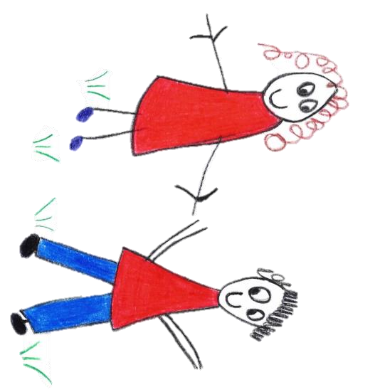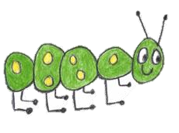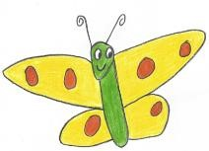

Hyde Heath Pre-School
Have fun and learn!

Registered Charity Number 1020591
Hyde Heath Infant School, Weedon Hill, Hyde Heath, Amersham, Bucks, HP6 5RW
Tel: 01494 782845

3.2 First aid

Policy statement
We are able to take action to apply first aid treatment in the event of an accident involving a child or adult. At least one adult with a current first aid certificate is on the premises, or on an outing, at any one time. Newly qualified staff who achieved an early years qualification at level 2 or 3 on or after 30 June 2016 also have a paediatric first aid certificate in order to be counted in the adult:child ratios. The first aid qualification includes first aid training for infants and young children. [We/I] have evidence of due diligence when choosing first aid training and ensure that it is relevant to adults caring for young children.

Procedures
The first aid kit
Our first aid kit is accessible at all times and contains multiples of quantities of:
- Triangular bandages (ideally at least one should be sterile).
- Sterile dressings:
- Small.
- Medium.
- Large.
- Composite pack containing assorted (individually-wrapped) plasters.
- Sterile eye pads (with bandage or attachment).
- safety pins.

In addition, the following equipment is kept near to the first aid box:
- 2 pairs of disposable plastic (PVC or vinyl) gloves.
- plastic disposable apron.
- A children’s forehead ‘strip’ thermometer.
- A supply of ice (icepack) is kept in the freezer.

- Information about who has completed first aid training and the location of the first aid box is provided to all our staff and volunteers. A list of staff and volunteers who have current PFA certificates is displayed in the setting.
- The first aid box is easily accessible to adults and is kept out of the reach of children.
- Staff check and replenish the first aid box contents.
- Medication is only administered in line with our Administering Medicines policy.
- In the case of minor injury or accidents, first aid treatment is given by a qualified first aider.
- In the event of minor injuries or accidents, we normally inform parents when they collect their child, unless the child is unduly upset or we have concerns about the injury. In which case we will contact the child’s parents for clarification of what they would like to do, i.e. whether they wish to collect the child and/or take them to their own GP.
- An ambulance is called for children requiring emergency treatment. We contact parents immediately and inform them of what has happened and where their child has been taken.
- Parents sign a consent form at registration allowing a member of staff to take their child to the nearest Accident and Emergency unit to be examined, treated or admitted as necessary on the understanding that they have been informed and are on their way to the hospital.
- Accidents and injuries are recorded in our accident record book and, where applicable, notified to the Health and Safety Executive, Ofsted and/or local child protection agencies in line with our Recording and Reporting of Accident and Incidents Policy.

Legal framework
- Health and Safety (First Aid) Regulations (1981)
Further guidance
- First Aid at Work: Your questions answered (HSE Revised 2015)
- Basic Advice on First Aid at Work (HSE Revised 2012)
- Guidance on First Aid for Schools (DfE Revised 2014)
This policy was adopted by | Hyde Heath Pre-School | (name of provider)
On | September 2020 | (date)
Date to be reviewed | September 2021 | (date)
Signed on behalf of the provider
Name of signatory
Role of signatory (e.g. chair, director or owner) | Chair of the Committee

