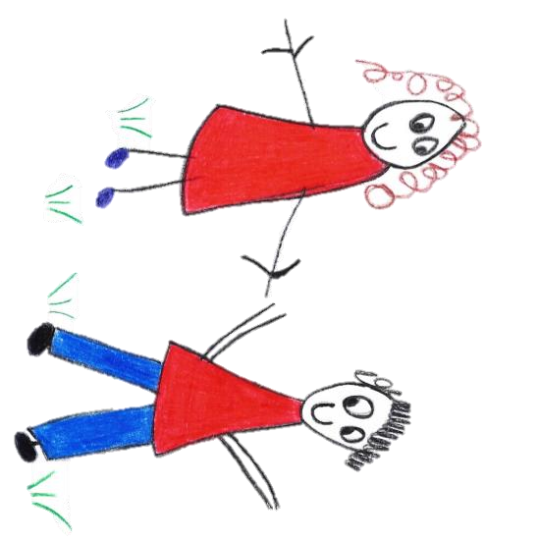

Hyde Heath Pre-school
Have fun and learn!

Registered Charity Number 1020591
Hyde Heath Infant School, Weedon Hill, Hyde Heath, Amersham, Bucks, HP6 5RW
Tel: 01494 782845

2.2 Student placements

Policy statement

We recognise that qualifications and training make an important contribution to the quality of the care and education we provide. As part of our commitment to quality, we offer placements to students undertaking early year’s qualifications and training. We also offer placements for school pupils on work experience.

We aim to provide for students on placement with us, experiences that contribute to the successful completion of their studies and that provide examples of quality practice in early years care and education.

Procedures

- We require students on qualification courses to meet the Suitable Person requirements of the Early Years Foundation Stage and have a satisfactory enhanced DBS check with barred list check(s).
- We require students in our setting to have a sufficient understanding and use of English to contribute to the well-being of children in our care.
- We require schools, colleges or universities placing students under the age of 17 years with us to vouch for their good character.
- We supervise students under the age of 17 years at all times and do not allow them to have unsupervised access to children.
- Students undertaking qualification courses who are placed in our setting on a short term basis are not counted in our staffing ratios.
- Students and apprentices, over the age of 17, who are undertaking a level 3 qualification may be considered to be counted in the ratios if our manager deems them to be suitably qualified and experienced.
- We take out employers' liability insurance and public liability insurance, which covers both students and voluntary helpers.
- We require students to keep to our Confidentiality and Client Access to Records Policy.
- We co-operate with students' tutors in order to help students to fulfil the requirements of their course of study.
- We provide students, at the first session of their placement, with a short induction on how our setting is managed, how our sessions are organised and our policies and procedures.
- We communicate a positive message to students about the value of qualifications and training.
- We make the needs of the children paramount by not admitting students in numbers that hinder the essential work of the setting.
- We ensure that trainees and students placed with us are engaged in bona fide early years training, which provides the necessary background understanding of children's development and activities.

This policy was adopted by | Hyde Heath Pre-School | (name of provider)
On | September 2020 | (date)
Date to be reviewed | September 2021 | (date)
Signed on behalf of the provider
Name of signatory
Role of signatory (e.g. chair, director or owner) | Chair of the Committee

