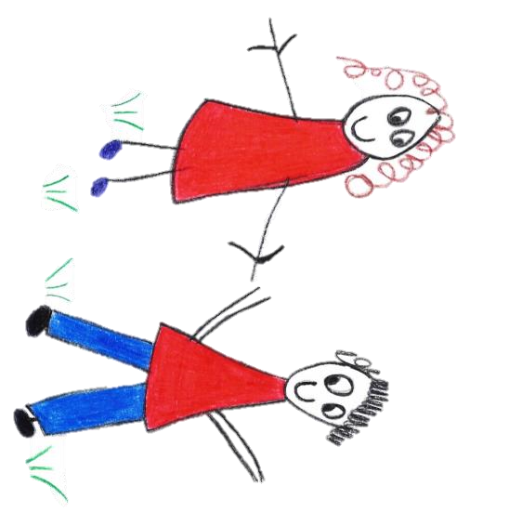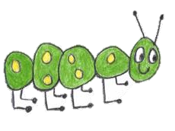

Hyde Heath Pre-school
Have fun and learn!

Registered Charity Number 1020591
Hyde Heath Infant School, Weedon Hill, Hyde Heath, Amersham, Bucks, HP6 5RW
Tel: 01494 782845

10.8 Transfer of records to school

Policy statement
We recognise that children sometimes move to another early years setting before they go on to school, although many will leave our setting to enter a nursery or reception class.

We prepare children for these transitions and involve parents and the receiving setting or school in this process. We prepare records about a child’s development and learning in the Early Years Foundation Stage in our setting; in order to enable smooth transitions, we share appropriate information with the receiving setting or school at transfer.

Confidential records are shared where there have been child protection concerns according to the process required by our Local Safeguarding Children Board.

The procedure guides this process and determines what information we can and cannot share with a receiving school or setting. Prior to transferring information, we will establish the lawful basis for doing so (see our Privacy Notice).

Procedures
Transfer of development records for a child moving to another early years setting or school
- Using the Early Years Outcomes (DfE 2013) guidance and our assessment of children's development and learning, the key person will prepare a summary of achievements in the seven areas of learning and development.
- The record refers to:
  - any additional language spoken by the child and his or her progress in both languages;
  - any additional needs that have been identified or addressed by our setting;
  - any special needs or disability, whether a CAF was raised in respect of special needs or disability, whether there is an Education, Health and Care Plan, and the name of the lead professional.
- The record contains a summary by the key person and a summary of the parent’s view of the child.
- The document may be accompanied by other evidence, such as photos or drawings that the child has made.
- If there have been any welfare or protection concerns, we place a star on the front of the assessment record.

Transfer of confidential information
- The receiving school or setting will need to have a record of any safeguarding or child protection concerns that were raised in our setting and what was done about them.
- We will make a summary of the concerns to send to the receiving setting or school, along with the date of the last professional meeting or case conference. Some Local Safeguarding Children Boards will stipulate the forms to be used and provide these for us to use.
- Where a CAF has been raised in respect of any welfare concerns, we will pass the name and contact details of the lead professional on to the receiving setting or school.
- Where there has been a s47 investigation regarding a child protection concern, we will pass the name and contact details of the child’s social worker on to the receiving setting or school – regardless of the outcome of the investigation.
- We post or take the information to the school or setting, ensuring it is addressed to the setting or school’s designated person for child protection and marked as 'confidential’.
- We do not pass any other documentation from the child's personal file to the receiving setting or school.
Legal framework
- General Data Protection Regulations (GDPR) (2018)
- Freedom of Information Act (2000)
- Human Rights Act (1998)
- Children Act (1989)
Further guidance
- What to do if you're worried a child is being abused: Advice for practitioners (HM Government 2015)
- Information sharing: Advice for practitioners providing safeguarding services to children, young people, parents and carers (HM Government 2015)

This policy was adopted by | Hyde Heath Pre-School | (name of provider)
On | September 2020 | (date)
Date to be reviewed | September 2021 | (date)
Signed on behalf of the provider
Name of signatory
Role of signatory (e.g. chair, director or owner) | Chair of the Committee

