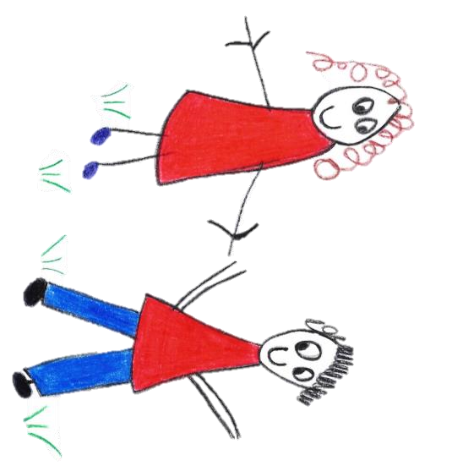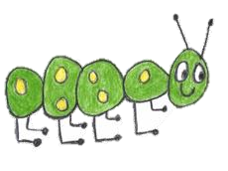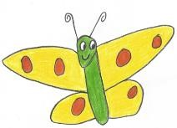

Hyde Heath Pre-school
Have fun and learn!

Registered Charity Number 1020591
Hyde Heath Infant School, Weedon Hill, Hyde Heath, Amersham, Bucks, HP6 5RW
Tel: 01494 782845

10.6b Learning Journals - Tapestry

Policy statement
We ensure that all children attending the setting have a personal Learning Journey which records photos, observations, and comments, in line with the Early Years Foundation Stage, to build up a record of each child’s achievements during their time with us.

It will also show children’s developmental progress through the different age bands of the EYFS.

EYFS key themes and commitments

A Unique Child | Positive Relationships | Enabling Environments | Learning and Development

Procedures
- Each child will have a Keyperson allocated to them who will be responsible for the compilation of that child’s Learning Journey.
- We use an online Learning Journey system (Tapestry), allowing staff and parents to access the information from any computer via a personal, password-protected login.
- Staff access allows input of new observations and photos or amendment of existing observations and photos.
- Parent access allows input of new observations and photos or the addition of comments on existing observations and photos – parent log-ins do not have the necessary permission to edit existing material.
- Observations input into the Tapestry system are moderated by a senior member of staff before being added to the child’s Learning Journey.
- Parents logging into the system are only able to see their own child’s Learning Journey.
- Parents are asked to sign a consent form giving permission for their child’s image to appear in other children’s Learning Journeys, and to protect images of other children that may appear in any photos contained in their child’s Learning Journey.
- The Learning Journey is started once the child has started in The Foundation Stage. During the first term, entries will be made more frequently as staff get to know the children.
- New observational entries to a child’s Learning Journey will usually be uploaded within two weeks of the observation being made.
- Observations are written in the present tense.
- In all written observations, other children are referred to as ‘C1’, ‘C2’, etc – and not by name.
- We will try wherever possible to allocate “Tapestry time” per week to each member of staff to enable them to upload observations. Any overflow will have to be completed in staff’s own time.
- Tapestry is not used as a general communication tool between prechool and home. A child’s learning journey is a document recording their learning and development and parents may add comments on observations or contribute photos, videos or information about activities they have been doing at home.
- Parents may contact us through the usual channels for any other day-to-day matters, e.g. absence, lost property, etc.

Security

- The Tapestry on-line Learning journey system is hosted on secure dedicated servers based in the UK.
- Access to information stored on Tapestry can only be gained by unique user id and password.
- Parents can only see their own child’s information and are unable to login to view other children’s Learning Journeys.

Once your child has left our setting we will either pass on their journal to their forwarding setting (providing they use Tapestry) or delete their information. Parents are required to notify Pre-School with their preference.

This policy was adopted by | Hyde Heath Pre-School | (name of provider)
On | September 2020 | (date)
Date to be reviewed | September 2021 | (date)
Signed on behalf of the provider
Name of signatory
Role of signatory (e.g. chair, director or owner) | Chair of the Committee

