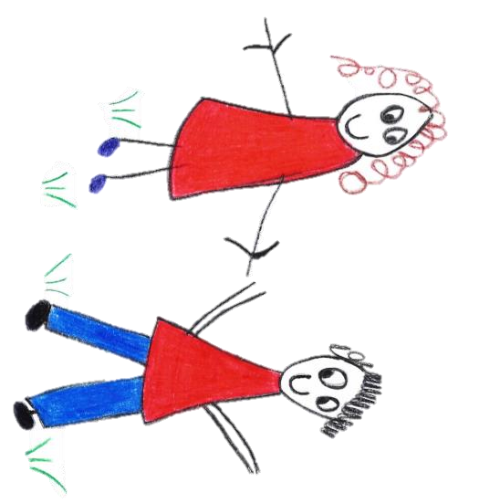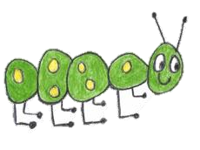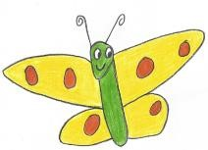
Hyde Heath Pre-school
Have fun and learn!

Registered Charity Number 1020591
Hyde Heath Infant School, Weedon Hill, Hyde Heath, Amersham, Bucks, HP6 5RW
Tel: 01494 782845

10.15 Schedule of Fees
Schedule of fees
Deposit amount | £25
Session Rate (9.00am until 12.00pm or 12.00pm until 3.00pm):
Children aged from 2 and a half years |  | £19.50 per session
Children aged 3 years or more |  | £18 per session
Other charges:
Late collection fee of £10 per additional 30 minutes.

