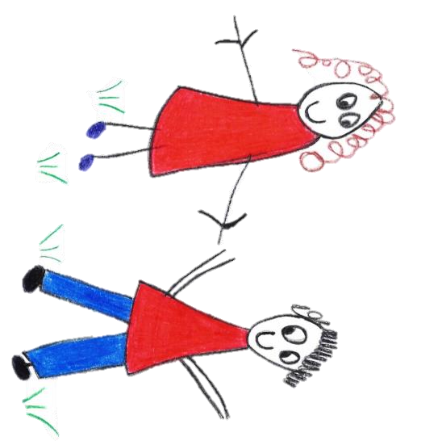

Hyde Heath Pre-school
Have fun and learn!

Registered Charity Number 1020591
Hyde Heath Infant School, Weedon Hill, Hyde Heath, Amersham, Bucks, HP6 5RW
Tel: 01494 782845

10.1 Information sharing

‘Sharing information is an intrinsic part of any frontline practitioners’ job when working with children and young people. The decisions about how much information to share, with whom and when, can have a profound impact on individuals’ lives. It could ensure that an individual receives the right services at the right time and prevent a need from becoming more acute and difficult to meet. At the other end of the spectrum it could be the difference between life and death.’

Information Sharing: Advice for practitioners providing safeguarding services to children, young people, parents and carers (HM Government 2015)

Policy statement

We recognise that parents have a right to know that the information they share with us will be regarded as confidential, as well as to be informed about the circumstances when, and the reasons why, we are obliged to share information.
We record and share information about children and their families (data subjects) in line with the six principles of the General Data Protection Regulations (GDPR) (2018) which are further explained in our Privacy Notice that is given to parents at the point of registration The six principles state that personal data must be:
- Processed fairly, lawfully and in a transparent manner in relation to the data subject.
- Collected for specified, explicit and legitimate purposes and not further processed for other purposes incompatible with those purposes.
- Adequate, relevant and limited to what is necessary in relation to the purposes for which data is processed.
- Accurate and where necessary, kept up to date.
- Kept in a form that permits identification of data subjects for no longer than is necessary for the purposes for which the data is processed.
- Processed in a way that ensures appropriate security of the persona data including protection against accidental loss, destruction or damage, using appropriate technical or organisational measures

We are obliged to share confidential information without authorisation from the person who provided it, or to whom it relates, if it is in the public interest. That is when:
- it is to prevent a crime from being committed or to intervene where one may have been, or to prevent harm to a child or adult; or
- not sharing it could be worse than the outcome of having shared it.

The responsibility for decision-making should not rely solely on an individual, but should have the back-up of the management team. The management team provide clear guidance, policy and procedures to ensure all staff and volunteers understand their information sharing responsibilities and are able to respond in a timely, appropriate way to any safeguarding concerns.

The three critical criteria are:
- Where there is evidence that the child is suffering, or is at risk of suffering, significant harm.
- Where there is reasonable cause to believe that a child may be suffering, or is at risk of suffering, significant harm.
- To prevent significant harm arising to children and young people or adults, including the prevention, detection and prosecution of serious crime.
Procedures

Our procedure is based on the GDPR principles as listed above and the seven golden rules for sharing information in the Information sharing Advice for practitioners providing safeguarding services to children, young people, parents and carers. We also follow the guidance on information sharing from the Local Safeguarding Children Board.

- Remember that the General Data Protection Regulations 2018 and human rights law are not barriers to justified information sharing as per the Children Act 1989, but provide a framework to ensure that personal information about living individuals is shared appropriately.

- Our policy and procedures on Information Sharing provide guidance to appropriate sharing of information both within the setting, as well as with external agencies.

- Be open and honest with the individual (and/or their family where appropriate) from the outset about why, what, how and with whom information will, or could be shared, and seek their consent, unless it is unsafe or if I have a legal obligation to do so. A Privacy Notice is given to parents at the point of registration to explain this further.

In our setting we ensure parents:
- receive a copy of our Privacy Notice and information about our Information Sharing Policy when starting their child in the setting and that they sign our Registration Form to say that they understand the circumstances in which information may be shared without their consent. This will only be when it is a matter of safeguarding a child or vulnerable adult;
- have information about our Safeguarding Children and Child Protection Policy; and
- have information about the other circumstances when information will be shared with external agencies, for example, with regard to any special needs the child may have or transition to school.

- Seek advice from other practitioners if you are in any doubt about sharing the information concerned, without disclosing the identity of the individual where possible.

- Our staff discuss concerns about a child routinely in supervision and any actions are recorded in the child’s file.
- Our manager routinely seeks advice and support from their line manager about possible significant harm.
- Our Safeguarding Children and Child Protection Policy sets out the duty of all members of our staff to refer concerns to our manager or deputy, as designated person, who will contact children’s social care for advice where they have doubts or are unsure.
- Our manager seeks advice if they need to share information without consent to disclose.

- Share with informed consent where appropriate and, where possible, respect the wishes of those who do not consent to share confidential information. You may still share information without consent if, in your judgement, there is good reason to do so, such as where safety may be at risk. You will need to base your judgement on the facts of the case. When you are sharing or requesting personal information from someone, be certain of the basis upon which you are doing so. Where you have consent, be mindful that an individual might not expect information to be shared.

- We base decisions to share information without consent on judgements about the facts of the case and whether there is a legal obligation.
- Our guidelines for consent are part of this procedure.
- Our manager is conversant with this and she is able to advise staff accordingly.

- Consider safety and well-being: Base your information sharing decisions on considerations of the safety and well-being of the individual and others who may be affected by their actions.

In our setting we:
- record concerns and discuss these with our designated person and/or designated officer from the management team for child protection matters;
- record decisions made and the reasons why information will be shared and to whom; and
- follow the procedures for reporting concerns and record keeping as set out in our Safeguarding Children and Child Protection Policy.

- Necessary, proportionate, relevant, adequate, accurate, timely and secure: Ensure that the information you share is necessary for the purpose for which you are sharing it, is shared only with those individuals who need to have it, is accurate and up-to-date, is shared in a timely fashion, and is shared securely.

- Our Safeguarding Children and Child Protection Policy and Children's Records Policy set out how and where information should be recorded and what information should be shared with another agency when making a referral.

- Keep a record of your decision and the reasons for it – whether it is to share information or not. If you decide to share, then record what you have shared, with whom and for what purpose.

- Where information is shared, we record the reasons for doing so in the child's file; where it is decided that information is not to be shared that is recorded too.

Consent
When parents choose our setting for their child, they will share information about themselves and their families. This information is regarded as confidential. Parents have a right to be informed that we will see their consent to share information in most cases, as well as the kinds of circumstances when we may not seek their consent, or may override their refusal to give consent. We inform them as follows:

- Our policies and procedures set out our responsibility regarding gaining consent to share information and when it may not be sought or overridden.
- We may cover this verbally when the child starts or include this in our prospectus.
- Parents sign our Registration Form at registration to confirm that they understand this.
- We ask parents to give written consent to share information about any additional needs their child may have, or to pass on child development summaries to the next provider/school.
- We give parents copies of the forms they sign.
- We consider the following questions when we assess the need to share:
- Is there a legitimate purpose to us sharing the information?
- Does the information enable the person to be identified?
- Is the information confidential?
- If the information is confidential, do we have consent to share?
- Is there a statutory duty or court order requiring us to share the information?
- If consent is refused, or there are good reasons for us not to seek consent, is there sufficient public interest for us to share information?
- If the decision is to share, are we sharing the right information in the right way?
- Have we properly recorded our decision?
- Consent must be freely given and informed - that is the person giving consent needs to understand why information will be shared, what will be shared, who will see information, the purpose of sharing it and the implications for them of sharing that information as detailed in the Privacy Notice.
- Consent may be, verbally but preferably in writing, or implicit, implied if the context is such that sharing information is an intrinsic part of our service or it has been explained and agreed at the outset.
- Consent can be withdrawn at any time.
- We explain our Information Sharing Policy to parents.

Separated parents
- Consent to share need only be sought from one parent. Where parents are separated, this would normally be the parent with whom the child resides. Where there is a dispute, we will consider this carefully.
- Where the child is looked after, we may also need to consult the Local Authority, as ‘corporate parent’ before information is shared.
All the undertakings above are subject to our paramount commitment, which is to the safety and well-being of the child. Please also see our Safeguarding Children and Child Protection Policy.

Legal framework
- General Data Protection Regulations (GDPR) (2018)
- Human Rights Act (1998)

Further guidance
- Information Sharing: Advice for practitioners providing safeguarding services to children, young people, parents and carers (HM Government 2015)
- What to do if you’re worried a child is being abused: Advice for practitioners (HM Government 2015)
- Working together to safeguard children: A guide to inter-agency working to safeguard and promote the welfare of children (HM Government 2015)

This policy was adopted by | Hyde Heath Pre-School | (name of provider)
On | September 2020 | (date)
Date to be reviewed | September 2021 | (date)
Signed on behalf of the provider
Name of signatory
Role of signatory (e.g. chair, director or owner) | Chair of the Committee

