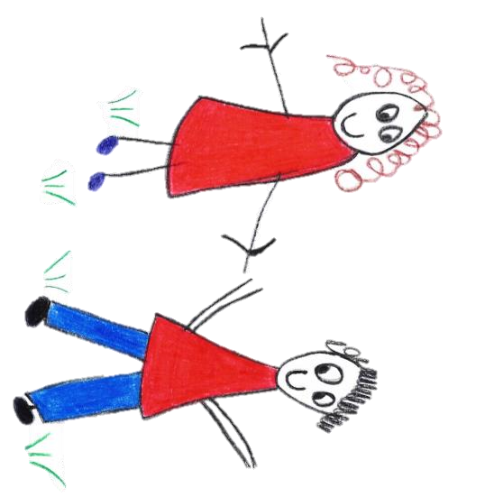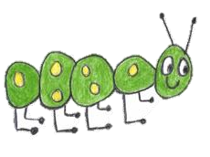

Hyde Heath Pre-school
Have fun and learn!

Registered Charity Number 1020591
Hyde Heath Infant School, Weedon Hill, Hyde Heath, Amersham, Bucks, HP6 5RW
Tel: 01494 782845

1.9 Lock Down Policy

Policy statement
Lock Down Policy Procedures In the event on an unauthorised person or persons trying to enter the Pre-School without permission then we will immediately instigate our Lock Down Procedures

Procedures

- A member of staff will immediately call 999 and collect the day care records, telephone and medications box to take to our ‘safe place’.
- The Manager and remaining members of staff will ring the emergency bell and gather all the children together into our ‘Safe Place’ which is in the toilet area next to our preschool room
- All lights will be turned off.
- One member of staff will count the children in the group whilst the Manager quickly checks the premises for any other children.
- Once we are sure that all the children and staff members are accounted for, we will lock ourselves into the room and await Police assistance.
- If OUTSIDE the Building without panic but with due urgency:
1. Usher all inside to the nearest room, unless unsafe to do so when an alternative should be communicated.
2. Check that there are no children or staff who miss the bell.
3. Close and lock doors (keys to be kept on hook by door) windows and other potential access points
- After the danger has passed and it is safe for us to leave our safe place we will under police instruction.
- Gather the children into the book corner whilst the Manager calls parents/carers to inform them what has happened. Ofsted and Early Years will be informed of the incident within 24hrs of the incident.

Legislation
Working Together to Safeguarding Children

This policy was adopted by | Hyde Heath Pre-School | (name of provider)
On | September 2020 | (date)
Date to be reviewed | September 2021 | (date)
Signed on behalf of the provider
Name of signatory
Role of signatory (e.g. chair, director or owner) | Chair of the Committee

