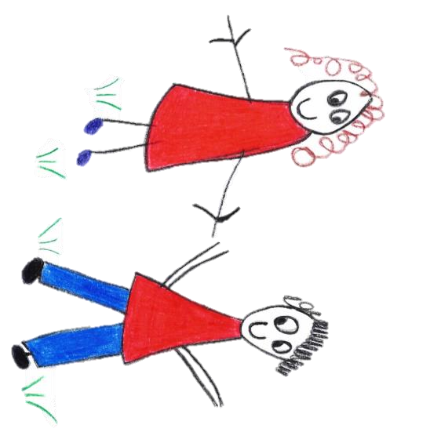

Hyde Heath Pre-school
Have fun and learn!

Registered Charity Number 1020591
Hyde Heath Infant School, Weedon Hill, Hyde Heath, Amersham, Bucks, HP6 5RW
Tel: 01494 782845

1.8 Storage of Information off Site
Policy statement
It is sometimes necessary for information regarding the children at Pre-School to be taken off site. This information may include documents that include the child’s name, photos or personal details including Learning Journeys, Typical Behaviours sheets, Reports from other Professionals etc. Pre-School laptops are removed from the premises to allow staff to work at home and contain information related to the children.

Procedures
All staff and Committee members (if relevant) are required to sign a declaration that any information removed from the Pre-School premises must be kept securely and confidentially at all times.The declaration states that:

Information will be kept securely in their home and not left for other people to be able to access. The house will be locked during the night.

Information should be transported securely and not left in any vehicle.

If Learning Journeys/Typical Behaviours sheets etc are taken off site, they must be on Pre-School premises when the child is in attendance (whether or not the staff member is due to be in the session).

Learning Journeys should not be left at home when staff members are working (regardless of whether the child is in the session).

All information relating to the children must be signed in and out of Pre-School on the necessary log and the Manager (or in her absence the Deputy) made aware.

Any children that are known to have Safeguarding issues or parents have asked that their photo not be in any other child’s learning journey (e.g. due to home circumstances) will not have anything with their name or photo removed from the Pre-School * (without prior discussion with the Manager). Keyworkers will be informed by the Manager which children this relates to.
* There are occasions when the SENCO or Designated Safeguarding Officers may need to attend a meeting off site and records must be taken with them. If there is no opportunity to return the records to Pre-School the same day, these documents must be kept securely by the staff member until returned to Pre-School.

Anything relating to any child at (or previously at) Pre-School stored electronically must be stored either on a Pre-School laptop or on the memory stick provided by Pre-School and not stored on personal computers or electronic equipment.

Documents relating to the children on the memory stick should be password protected (with the allocated Pre-School password) and children’s initials (not full names) to file the document. Once the document has been transferred to the Pre-School laptop, it should be deleted from the memory stick. All data on the laptop or memory stick is encyrpted.

Pre-School cameras/memory cards should not be removed from the Pre-School premises unless for events attended by children and staff. Photos are uploaded to the Manager’s laptop for printing on a weekly basis. Parents agree that photos can be stored on the laptop and used for internal books etc.

On leaving Pre-School employment all information and equipment relating to the Pre-School will be returned prior to leaving date (i.e. memory stick, handbooks, policies etc).

This policy was adopted by | Hyde Heath Pre-School | (name of provider)
On | September 2020 | (date)
Date to be reviewed | September 2021 | (date)
Signed on behalf of the provider
Name of signatory
Role of signatory (e.g. chair, director or owner) | Chair of the Committee

