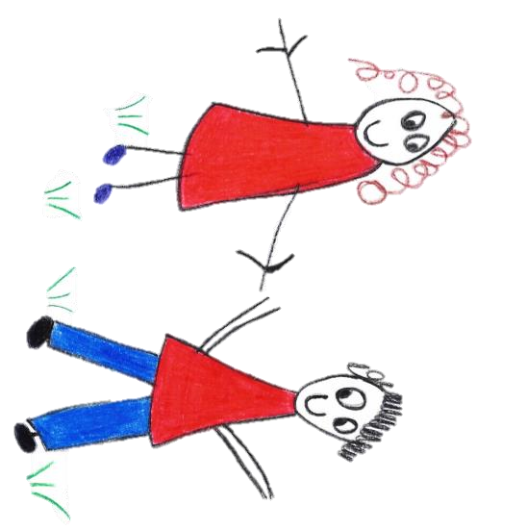

Hyde Heath Pre-school
Have fun and learn!

Registered Charity Number 1020591
Hyde Heath Infant School, Weedon Hill, Hyde Heath, Amersham, Bucks, HP6 5RW
Tel: 01494 782845
1.4 Uncollected child

Policy statement

In the event that a child is not collected by an authorised adult by their expected collection time, we put into practice agreed procedures. The child will receive a high standard of care to cause as little distress as possible.

We inform parents/carers of our procedures so that, if they are unavoidably delayed, they will be reassured that their children will be properly cared for.

Procedures
- Parents are asked to provide the following specific information when their child starts attending our setting, which is recorded on our Registration Form:
- Home address and telephone number - if the parents do not have a telephone, an alternative number must be given, perhaps a neighbour or close relative.
- Place of work, address and telephone number (if applicable).
- Mobile telephone number (if applicable).
- Names, addresses, telephone numbers and signatures of adults who are authorised by the parents to collect their child from the setting, for example a childminder or grandparent.
- Who has parental responsibility for the child.
- Information about any person who does not have legal access to the child.
- On occasions when parents are aware that they will not be at home or in their usual place of work, they inform us in writing of how they can be contacted.
- On occasions when parents, or the persons normally authorised to collect the child, are not able to collect the child, they provide us with written details of the name, address and telephone number of the person who will be collecting their child. We agree with parents how to verify the identity of the person who is to collect their child.
- Parents are informed that if they are not able to collect the child as planned, they must inform us so that we can begin to take back-up measures. Our contact telephone number is 01494 782845.
- If a child is not collected at their expected collection time, we follow the procedures below:
- The child’s file is checked for any information about changes to the normal collection routines.
- If no information is available, parents/carers are contacted at home or at work.
- If this is unsuccessful, the adults who are authorised by the parents to collect their child - and whose telephone numbers are recorded on the Registration Form - are contacted.
- All reasonable attempts are made to contact the parents or nominated carers.
- The child does not leave the premises with anyone other than those named on the Registration Form or in their file.
- If no-one collects the child within 30 minutes of their expected collection time and there is no named contact who can be contacted to collect the child, we apply the procedures for uncollected children.
- We contact the local authority children’s social care team:
- If the children’s social care team is unavailable we will contact the local police
First Response Service 01296 383962

- Or the out of hours duty officer (where applicable):
0800 9997677
- After an additional 15 minutes if the child has not been collected, we will contact the above statutory agencies again.
- The child stays at the setting in the care of two of our fully-vetted workers, one of whom will be our manager or deputy manager until the child is safely collected either by the parents or by a social care worker.
- Social care will aim to find the parent or relative. If they are unable to do so, the child will become looked after by the local authority.
- Under no circumstances will we go to look for the parent, nor leave the setting premises with the child.
- We ensure that the child is not anxious and we do not discuss our concerns in front of them.
- A full written report of the incident is recorded in the child’s file.
- Depending on circumstances, we reserve the right to charge parents for the additional hours worked.
- Ofsted may be informed:
0300 123 1231

- Buckinghamshire Pre-school Learning Alliance office/Development Worker may also be informed:
01908 263700

This policy was adopted by |  | Hyde Heath Preschool | (name of provider)
On |  | Sept 2020 | (date)
Date to be reviewed |  | Sept 2021 | (date)
Signed on behalf of the provide
Name of signatory
Role of signatory (e.g. chair, director or owner) | Chair of the Committee

Other useful Pre-school Learning Alliance publications
- Safeguarding Children (2013)

