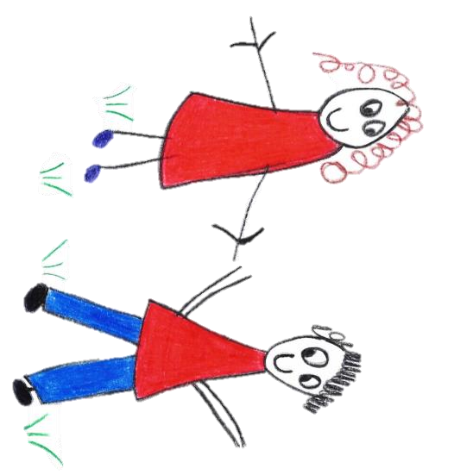
Hyde Heath Pre-school
Have fun and learn!
Registered Charity Number 1020591
Hyde Heath Infant School, Weedon Hill, Hyde Heath, Amersham, Bucks, HP6 5RW
Tel: 01494 782845

Appendix to Safeguarding Policy The Prevent Duty & Promoting British Values
Registered early years childcare providers are subject to a duty under section 26 of the Counter-Terrorism and Security Act 2015, in the exercise of their functions, to have “due regard to the need to prevent people from being drawn into terrorism”. This duty is known as the Prevent duty. Here at Hyde Heath Pre-School we take Safeguarding very seriously, therefore to ensure that we adhere to and achieve the Prevent duty we will;
• Provide appropriate training for staff as soon as possible. Part of this training will enable staff to identify children who may be at risk of radicalisation
• We will build the children’s resilience to radicalisation by promoting fundamental British values and enabling them to challenge extremist views (for early years providers the statutory framework for the EYFS sets standards for learning, development and care for children from 0-5, thereby assisting their personal, social and emotional development and understanding of the world)
• We will assess the risk, by means of a formal risk assessment, of children being drawn into terrorism, including support for extremist ideas that are part of terrorist ideology
• We will ensure that our staff understand the risks so that they can respond in an appropriate and proportionate way
• We will be aware of the online risk of radicalisation through the use of social media and the internet
• As with managing other safeguarding risks, our staff will be alert to changes in children’s behaviour which could indicate that they may be in need of help or protection (children at risk of radicalisation may display different signs or seek to hide their views). The Key Person approach means we already know our key children well and so we will notice any changes in behaviour, demeanour or personality quickly
• We will not carry out unnecessary intrusion into family life but we will take action when we observe behaviour of concern. The key person approach means that we already have a rapport with our families so we will notice any changes in behaviour, demeanour or personality quickly
• We will work in partnership with our LSCB for guidance and support We will build up an effective engagement with parents/carers and families. (This is important as they are in a key position to spot signs of radicalisation) We will assist and advise families who raise concerns with us. It is important to assist and advise families who raise concerns and be able to point them to the right support mechanisms. We will ensure that our DSO’s will undertake Prevent awareness training (as a minimum) so that they can offer advice and support to other members of staff. We will ensure that any resources used in the nursery are age appropriate for the children in our care and that our staff have the knowledge and confidence to use the resources effectively.

- Procedures to follow-

- We ensure that all staff or volunteer know how to raise concerns about a child or adult within the setting.
- We refer concerns to First Response and co-operate fully in any subsequent investigation (First Response Service 01296 383962). NB In some cases this may mean the police or another agency identified by the Bucks Safeguarding Children Board.
- We refer any such complaint immediately to the Local Authority Designated Officer (LADO) to investigate:
Tel: 01296 382070
- We also report any such alleged incident to Ofsted, as well as what measures we have taken. We are aware that it is an offence not to do this.
- We co-operate entirely with any investigation carried out by children’s social care in conjunction with the police.

This policy was adopted by | Hyde Heath Pre-School | (name of provider)
On | September 2020 | (date)
Date to be reviewed | September 2021 | (date)
Signed on behalf of the provider
Name of signatory
Role of signatory (e.g. chair, director or owner) | Chair of the Committee

