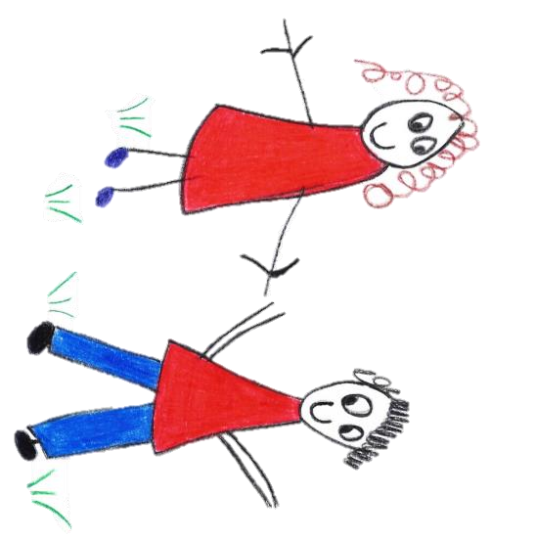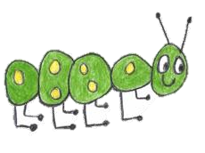
Hyde Heath Pre-school
Have fun and learn!
Registered Charity Number 1020591
Hyde Heath Infant School, Weedon Hill, Hyde Heath, Amersham, Bucks, HP6 5RW
Tel: 01494 782845

1.10 Image Use Policy

Policy statement

This policy seeks to ensure that images and videos taken within and by Hyde Heath Pre-School are taken and held legally and the required thought is given to safeguarding all members of the setting. It applies to all images (including still and video content) taken by the setting.

It applies to all staff, the management committee, volunteers, students, visitors to the setting and other individuals who work for or provide services to Hyde Heath Pre-School as well as parents/guardians and children.

This policy forms part of our Safeguarding Children procedures and should be read in conjunction with the following policies and procedures:
- Safeguarding and Child Protection
- Allegations of abuse against staff members
- Online Safety
- Acceptable Use
- Mobile Phones and Recording Devices
- Confidentiality

All images taken by the setting will be used in a manner respectful of the eight Data Protection Principles (Data Protection Act 1998). This means that images will be:
- fairly and lawfully processed
- processed for limited, specifically stated purposes only
- used in a way that is adequate, relevant and not excessive
- accurate and up to date
- kept on file for no longer than is necessary
- processed in line with an individual’s legal rights
- kept securely
- adequately protected if transferred to other countries

The settings Designated Safeguarding Person Claire Rutherford is responsible for ensuring the acceptable, safe use and storage of all camera technology and images within Hyde Heath Pre-School. This includes the management, implementation, monitoring and review of this Image Use Policy. In addition, the DSL has the authority to view any images taken and/or to withdraw or modify a member of staff’s authorisation to take images at any time. All members of staff, students, volunteers, visitors and parents should be aware that all images taken within the setting are available for scrutiny and that they must be able to justify any images in their possession.
Where concerns are raised, or disclosures made, regarding suspicious activity relating to the use of images the Designated Safeguarding Lead will contact the Buckinghamshire Local Authority Designated Officer (LADO) for advice. The LADO contact for our setting is: 01296 382070

Procedures
Parental Consent
- Written permission from parents/guardians will always be obtained before images/videos of children are taken, used or published.
- Written parental consent will always be sought to take and use photographs offsite for professional, marketing and training purposes. This may be in addition to parental permission sought for onsite images.
- Written consent from parents/guardians will be kept by the setting where children’s images are used for publicity purposes (such as brochures or publications), until the image is no longer in use.
- Parental permission will be sought on an annual basis for general consent and on a case by case basis for specific events.
- A record of all consent details will be kept securely on file. Should permission be withdrawn by parents/guardians at any time, then all relevant images will be removed and disposed of and the record will be updated accordingly.

Safety of Images and Videos
- All images taken and processed by or on behalf of the setting will take place using only equipment and devices provided by Hyde Heath Pre-School.
- Staff will receive information regarding the safe and appropriate use of images as part of their safeguarding training and responsibilities.
- All members of staff (including volunteers) will ensure that all images are available for scrutiny and will be able to justify any images in their possession.
- Images will not be kept for longer than is to be considered necessary. All staff are responsible for ensuring that all photographs are permanently wiped from memory cards, computer hard and portable drives or other relevant devices once the images will no longer be of use. This will be monitored by the Designated Safeguarding Person.
- All images will remain on site at all times, unless prior explicit consent has been given by both the DSP and the parent/guardian of any child or young person captured in any photograph.
- Should permission be given to take any images off site then all relevant details will to be recorded, for example who, what, when and why and data will be kept securely (e.g. with appropriate encryption).
- Any memory stick, CD or storage device containing images of children to be taken offsite for further work will be suitably encrypted and will be logged in and out by the DSP and monitored to ensure that it is returned within the expected time scale.
- The DSP reserves the right to view any images taken and/or to withdraw or modify a member of staffs’ authorisation to take or make images at any time.
- Only official setting owned equipment (e.g. work provided digital or video cameras, tablets, mobile phones, etc) will be used by staff to capture images of children for official purposes. Use of personal cameras by staff is prohibited at all times.
- Any apps, websites or third party companies used to share, host or access children’s images will be risk assessed prior to use.
- The setting will ensure that images always are held in accordance with the Data Protection Act 1998 and suitable child protection requirements (if necessary) are in place.
- Photographs will be disposed of should they no longer be required. They will be returned to the parent or carer, deleted and wiped or shredded as appropriate. Copies will not to be taken of any images without relevant authority and consent from the DSL and the parent/carer.

Publication and sharing of images and videos
- Images or videos that include children will be selected carefully for use e.g. only using images of children who are suitably dressed.
- Images or videos that include children will not provide material which could be reused.
- Children’s’ full names will not be used on the website or other publication (e.g. newsletters, social media channels) in association with photographs or videos.
- The setting will not include any personal information on video, on the website, in a prospectus or in other printed publications.
- Any parents/guardians and staff members with particular concerns must always be able to withhold their consent for the publication or sharing of images for whatever reason.

Usage of systems to share images with parents
- Hyde Heath Pre-School uses a closed Facebook group to upload and share images of children with parents.
- The use of Facebook has been appropriately risk assessed and the setting has taken steps to ensure all data stored is held in accordance with the Data Protection Act 1998 (as above).
- Images uploaded to Facebook will only be taken using the setting’s devices.
- All users authorised to upload images to Facebook are advised on safety measures to protect all members of the community e.g. using strong passwords, logging out of systems after use etc.
- Parents/guardians will be informed of the settings expectations regarding safe and appropriate use (e.g. not sharing passwords or copying and sharing images) prior to being given access. Failure to comply with this may result in access being removed.

Safe Practice when taking images and videos
- Careful consideration is given before involving very young or vulnerable children when taking photos or recordings, who may be unable to question why or how activities are taking place.
- The setting will discuss the use of images with children in an age appropriate way.
- A child’s right not to be photographed is to be respected. Images will not be taken of any child against their wishes.
- Photography is not permitted in sensitive areas such as toilets.

Use of Images/Videos of Children by Others
Use of Photos/Videos by Parents/Guardians at events
- Parents/guardians are permitted to take photographs or video footage of events for private use only.
- Parents/guardians who are using photographic equipment must be mindful of others when making and taking images.
- The opportunity for parents/guardians to take photographs and make videos can be reserved by the setting on health and safety grounds.
- Parents/guardians are only permitted to take or make recording within designated areas of the setting. Photography is not permitted in sensitive areas such as toilets.
- The right to withdraw consent will be maintained and any photography or filming on site will be open to scrutiny at any time.
- Parents may contact the setting DSP to discuss any concerns regarding the use of images.
- Photos and videos taken by the setting and shared with parents should not be shared elsewhere (e.g. posted on social media site), to do so may breach intellectual property rights, data protection legislation and importantly may place members of the community at risk of harm.

Use of Photos/Videos by Children
- The setting will discuss and agree age appropriate acceptable use rules with children regarding the appropriate use of cameras, such as places children cannot take the camera (e.g. unsupervised areas, toilets etc.).
- All staff will be made aware of the acceptable use rules regarding children’s use of cameras and will ensure that children are appropriately supervised when taking images.
- Members of staff will role model positive behaviour to the children by encouraging them to ask permission before they take any photos.
- Photos taken by children for official use will only be taken with parental consent and will be processed in accordance with the Data Protection Act 1998.
- Parents/carers will be made aware that children will be taking photos/videos of other children and will be informed how these images will be managed by the setting e.g. will be for internal use by the setting only (not shared online or via any website or social media tool).
- Photos taken by children for official use will be carefully controlled by the setting and will be checked carefully before sharing online or via digital screens.
- Still and video cameras provided for use by children and the images themselves will not be removed from the setting.

Use of Images of Children by the Media
- Where a press photographer is to be invited to celebrate an event, every effort will be made to ensure that the newspaper’s (or other relevant media) requirements can be met.
- A written agreement will be sought between parents and carers and the press which will request that a pre-agreed and accepted amount of personal information (e.g. first names only) will be published along with images and videos.
- The identity of any press representative will be verified, and access will only be permitted where the event is planned, and where press are to be specifically invited to attend. No authorisation will be given to unscheduled visits by the press under any circumstances.
- Every effort will be made to ensure the press abide by any specific guidelines should they be requested. No responsibility or liability however can be claimed for situations beyond reasonable control, and where the setting is to be considered to have acted in good faith.

Use of Professional Photographers
- Professional photographers who are engaged to record any events will be prepared to work according to the terms of the settings Online Safety policy.
- Photographers will sign an agreement which ensures compliance with the Data Protection Act and that images will only be used for a specific purpose, subject to parental consent.
- Photographers will not have unsupervised access to children.

This policy was adopted by | Hyde Heath Pre-School | (name of provider)
On | Sept 2020 | (date)
Date to be reviewed | Sept 2021 | (date)
Signed on behalf of the provider
Name of signatory
Role of signatory (e.g. chair, director or owner) | Chair of the Committee

